**The role of present-day speciation in modern dynamics of vertebrate diversity**

Alternative title: Present-day speciation rates do not generate modern terrestrial vertebrate cradles and museums

Alternative title: Present-day speciation rates do not generate modern dynamics of terrestrial vertebrate diversity

Alternative title: Recent tetrapod cradles are not the result of present-day speciation

Alternative: Is recent speciation rate the driver of modern diversity dynamics? A global assessment with terrestrial vertebrates

Alternative: Modern dynamics of vertebrate diversity: the role of present-day speciation rates in shaping cradles and museums.

Alternative: Phylogenetic diversity does not match with species richness patterns

Alternative: Factors generating modern patterns of phylogenetic diversity in vertebrates//Shared patterns of phylogenetic diversity among vertebrates indicate a common driver

Modern dynamics of vertebrate diversity suggest a differential role of environmental changes and life-history traits across the globe

Global geographic patterns of vertebrate diversity dynamics

Abstract

Evolutionary and ecological dynamics differ across regions of Earth and across clades of tree of life.

Introduction

The evolutionary and ecological processes underlying global patterns of biodiversity have always been a central subject of study for evolutionary biologists (Fischer 1960; MacArthur 1964). The study of geographic patterns of species diversity has led the macroecological discussion from the very beginning of evolutionary biology as a discipline, being among the major topics in the works that paved the way for the modern evolutionary theory (Humboldt and Bonpland 1807; Darwin 1859; Wallace 1876). The biodiversity levels in a given area are ultimately determined by three fundamental processes: lineage origination (generally represented by speciation in macroevolutionary studies of extant taxa), extinction, and dispersal (REF). These processes, and therefore the differences in richness across geographic and phylogenetic contexts, might be subjected to multiple biotic and abiotic factors, such as ecological interactions (REF), evolutionary time (REF), ecomorphological dynamics (REF), environmental conditions (REF), climatic trends (REF), or topography and plate tectonics (REF).

In recent years, the emergence and development of what is known as spatial phylogenetics (Mishler 2023) has fostered the advancement of our understanding of macroecological dynamics by integrating the phylogenetic component into the study of geographic biodiversity patterns. Specifically, the use of phylogeny-based metrics of biodiversity such as phylogenetic diversity (PD) allows for the investigation of the relatedeness of biodiversity across geographic scales (high PD indicates the presence of species distantly related in the phylogeny, while low PD is the result of closely related species in a given area). This, in turn, may greatly enhance our ability to understand the evolutionary, ecological, and environmental factors that shape diversity dynamics (Davies and Buckley 2011), as well as being an essential source of information for conservation purposes (Faith 1992).

Even though richness and PD are in general positively correlated (i.e., regions of high and low richness have generally high and low PD, respectively), spatial patterns of the two are not exactly coincidental (e.g., REF). In other words, there are geographic areas that harbor higher and lower PD than expected for their richness levels – i.e., areas where species are more distantly or more closely related, respectively, than would be predicted by the number of species (Fig. 1). Identifying these deviations of PD from richness (residual PD; Velasco et al. 2022) is key to understanding the processes underlying diversity patterns and investigating evolutionary scenarios plausible with such existing patterns.

At local or regional scales, levels of residual PD might reflect the existence of biotic or abiotic filters in the community assembly. In this case, low residual PD could reflect an assembly governed by strong abiotic (e.g., habitat) filtering, leading to the coexistence of closely related species which, considering niche conservatism principles, would presumably be ecologically similar (REF). In contrast, high residual PD would primarily reflect biotic (e.g., competence) filtering, resulting in the coexistence of species with different ecological affinities and likely more distantly related phylogenetically. At broader scales, geographic differences in residual PD may arise due to the differential persistence of lineages through time, which can result in some regions having a higher proportion of older, more evolutionarily distinct lineages than others. This, in turn, can be affected by a variety of factors, such as differences in habitat stability, dispersal events, or diversification rates. More specifically, regions of high residual PD (i.e., with species more distantly related to each other than predicted by richness) might result from gradual accumulation of species, either by dispersal from other areas (immigration) or by low levels of speciation and extinction (low turnover rate), acting as a reservoir of ancient lineages. This could reflect what has been commonly known in the evolutionary biology literature as a “museum” of biodiversity (Stebbins 1974; other REFS). However, high levels of residual PD might also arise with a different combination of processes, such as high speciation rates in the past followed by low extinction of those ancient lineages, or exceptionally high extinction rates of young lineages. Conversely, regions of low residual PD (i.e., with species more closely related than expected by richness) can result from exceptionally high speciation and extinction rates maintained through time (high turnover rate), which constitute the original conceptualization of a “cradle” of biodiversity (REF). However, again, low residual PD can also be the result of other scenarios, such as reduced extinction rates of recent lineages or increased extinction of ancient clades. This multiplicity of scenarios generating patterns of lineage and phylogenetic diversity highlights the importance of investigating the underlying evolutionary processes rather than focusing the discussion on dichotomously dilucidating whether specific regions are cradles or museums of biodiversity (Vasconcelos et al. 2022).

The increasing availability of global distribution and phylogenetic data for large clades of the tree of life allows for the exploration of large-scale diversity patterns and evolutionary processes. For example, in the last decade, the geographic distribution of residual phylogenetic diversity has been addressed for the major clades of terrestrial vertebrates: mammals (Davies and Buckley 2011), amphibians (Fritz and Rahbek 2012), birds (Voskamp et al. 2017), and squamates (Gumbs et al. 2020; Vásquez-Restrepo et al. 2023). However, a comprehensive exploration including mapping residual PD and identifying similarities and differences across vertebrate clades, as well as analyzing the potential effect of different factors on such patterns, is still lacking. In this study, we characterize geographic patterns of current tetrapod diversity dynamics by inferring species and phylogenetic diversity, and test hypotheses related to the impact of multiple factors on regional levels of residual PD: recent speciation rates, evolutionary time, and environmental conditions. This allows us to identify regions in which the evolutionary history has been potentially subjected to different processes shaping the observed patterns. Ultimately, this constitutes a step forward in our understanding of evolutionary dynamics and, importantly, might provide an impactful insight into how to confront the challenges imposed by the global environmental crisis.

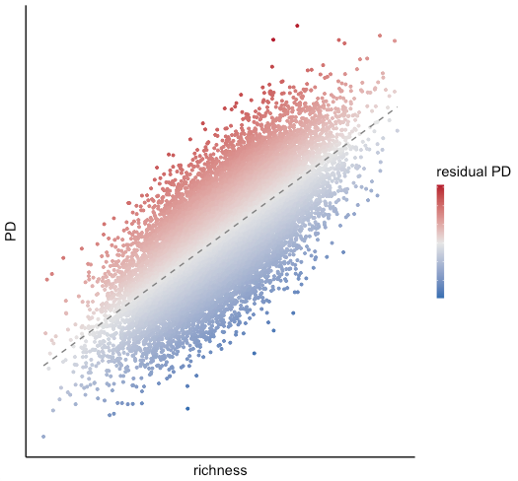

Figure 1. Schematic representation of the relationship between species richness (X-axis) and phylogenetic diversity (Y-axis), with color representing residual phylogenetic diversity.

Materials and Methods & Results

Data

We calculated phylogenetic diversity (PD): how related species in a region are.

with 100 trees from the posterior (tree_samp100.rds), and get the average values across the 100 grids.

Then, we did a local regression (LOESS) of PD versus species richness. The linear model residuals show regions with high or low phylogenetic diversity accounting for species richness (residual PD). High residuals means high PD for a given richness (museums), while low residuals show low PD (pumps).

We also calculated spatial DR, a measure of current speciation rates, averaging the values obtained for the posterior trees (100 trees).

We identified focal regions of high and low residual PD, representing putative museums (distantly related species) and putative cradles (closely related species), respectively.

LTT plots (potential effect of time/age on present-day diversity dynamics)

I don’t think there are any patterns that we can discuss just by looking at the plots, apparently there are no clear differences between museums and cradles in their way of faunal build-up (we would need fossils to look at the full picture of lineage accumulation). I am not sure that analyzing the data in some manner would help in the interpretation.

Environmental variables

Potential effects of climate and environment on current diversity dynamics.

Temperature and precipitation

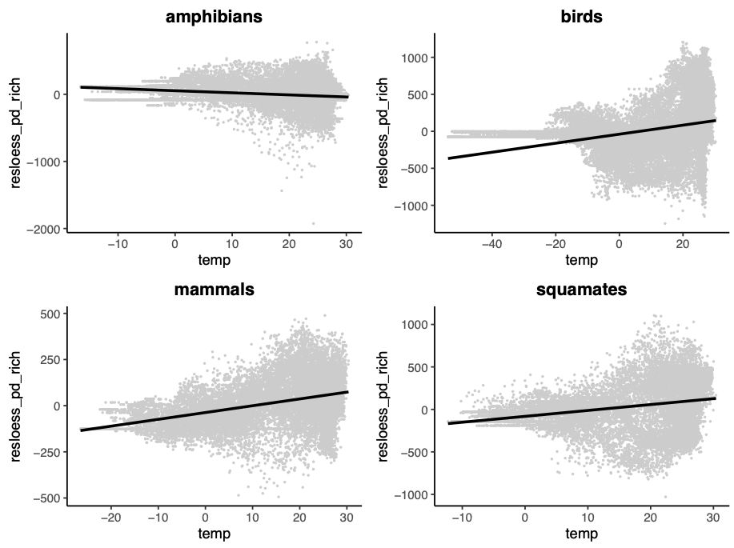

Residual PD vs Temperature. R2: amphibians 0.032, birds 0.09, mammals 0.14, squamates 0.065.

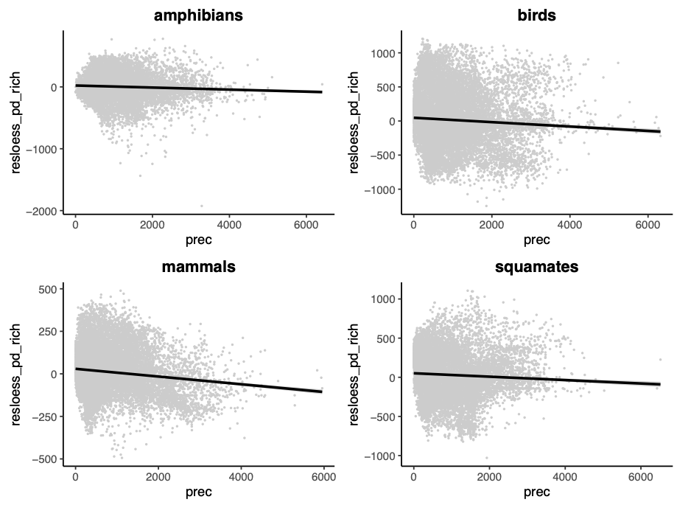

Residual PD vs Precipitation. R2: amphibians 0.004, birds 0.005, mammals 0.017, squamates 0.004.

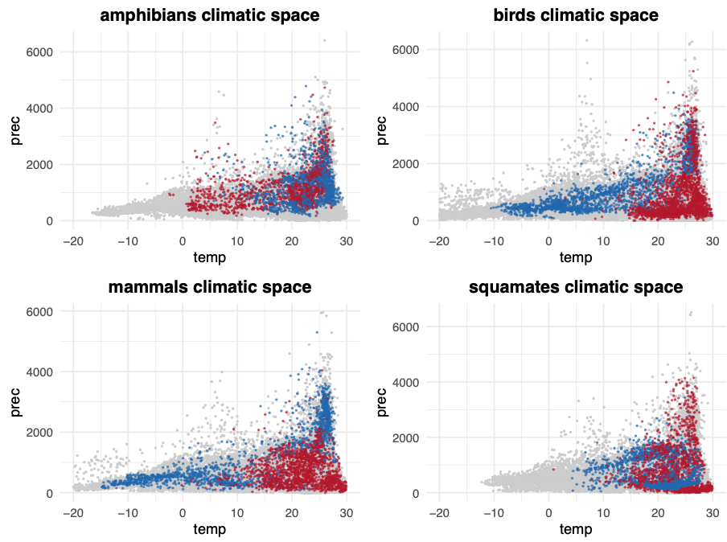

Climatic space (temperature vs precipitation) of cradles (blue) and museums (red) for each group of tetrapods.

Temperature and precipitation seasonality

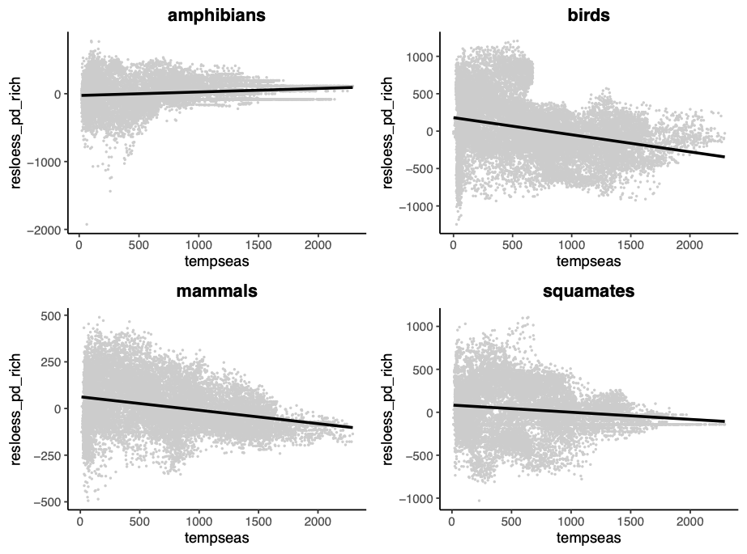

Residual PD vs temperature seasonality. R2: amphibians 0.018, birds 0.09, mammals 0.08, squamates 0.018.

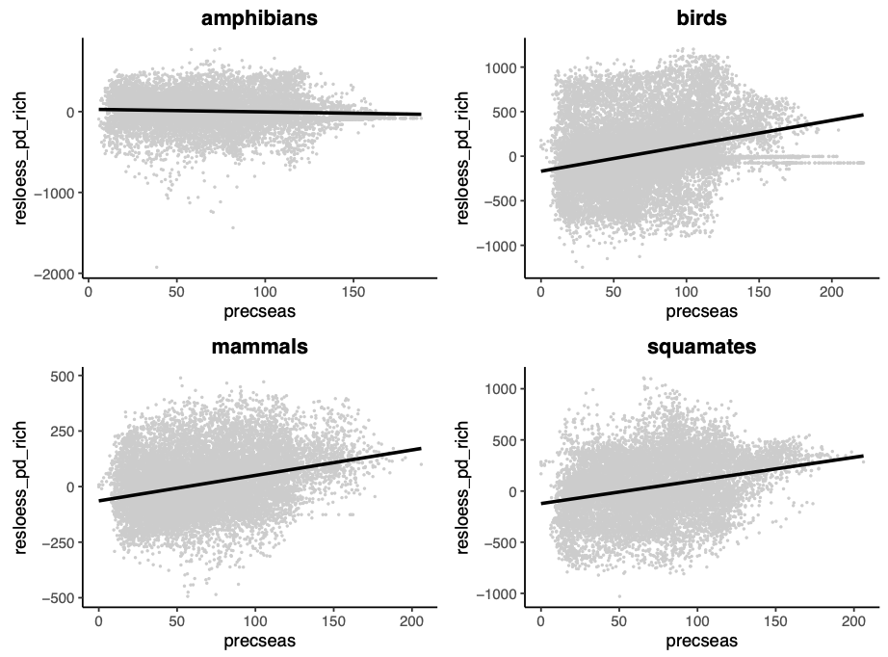

Residual PD vs precipitation seasonality. R2: amphibians 0.003, birds 0.077, mammals 0.092, squamates 0.080.

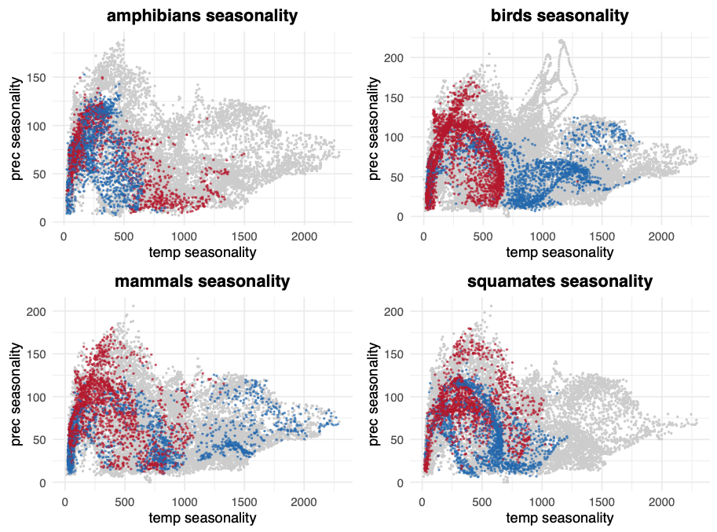

Temperature seasonality vs precipitation seasonality of cradles (blue) and museums (red) for each group of tetrapods.

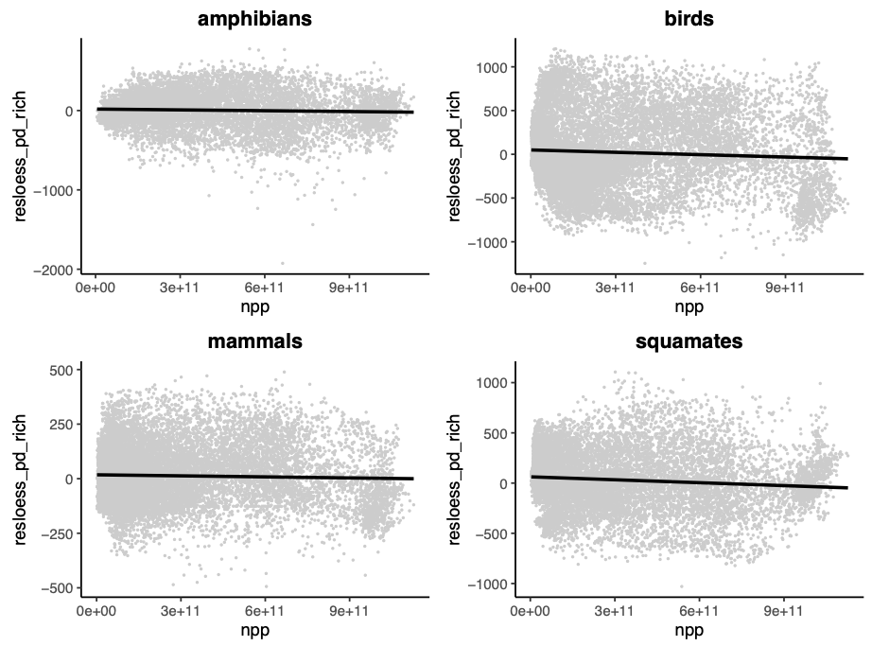

Residual PD vs Net Primary Productivity. R2: amphibians 0.002, birds 0.004, mammals 0.001, squamates 0.01.

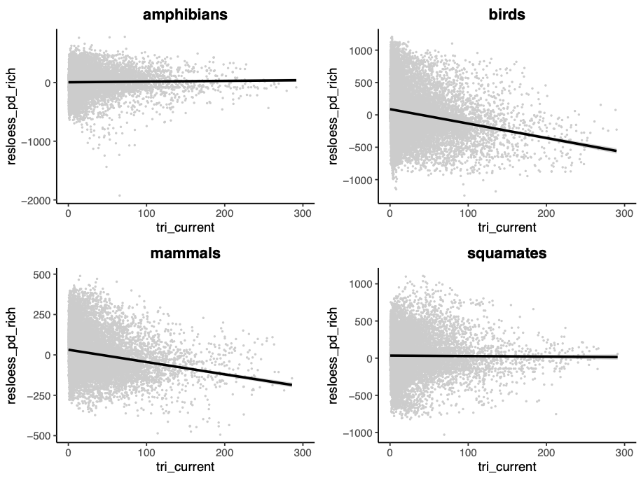

Residual PD vs Topographic complexity (tri). R2: amphibians 0.0004, birds 0.0397, mammals 0.0414, squamates 0.00008.

Latitude plots

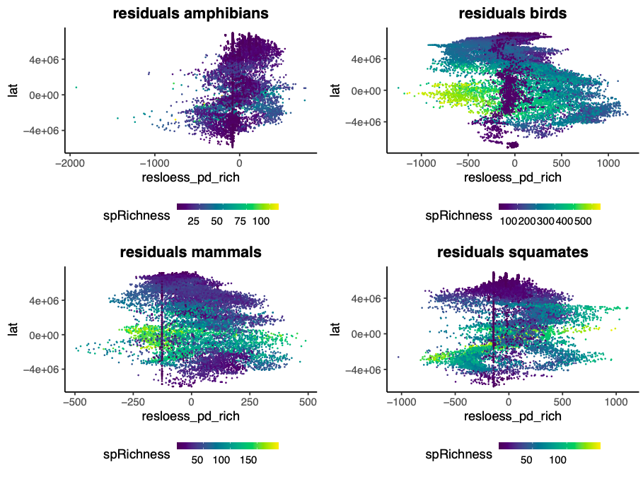

Latitudinal gradient of residuals (PD ~ richness) colored by richness. Positive residual values indicate high PD relative to richness in the grid cell (museums in the extreme positive values). Negative values indicate low PD relative to richness (cradles in the extreme negative values).

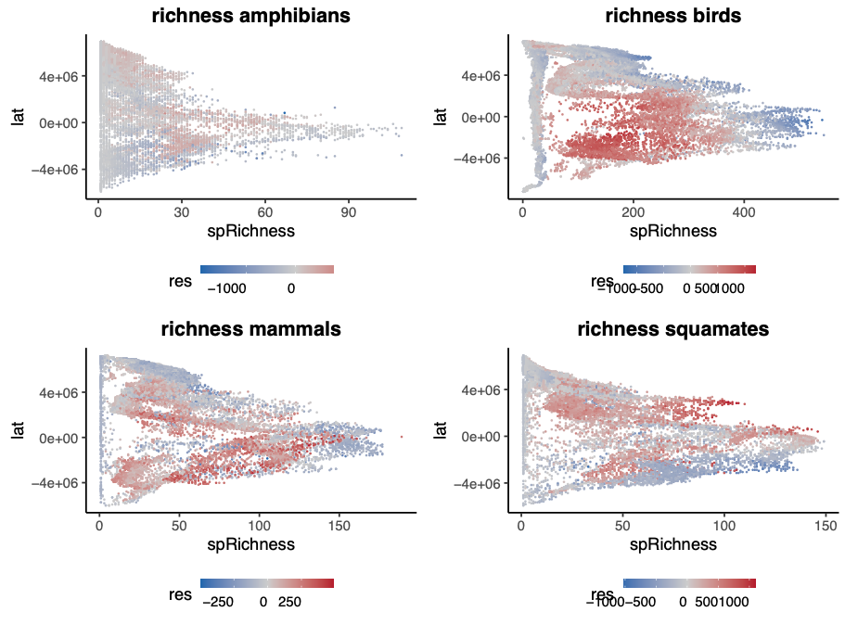

Latitudinal diversity gradient colored by residuals (PD ~ richness): cradles in blue and museums in red.

Richness vs residuals (PD ~ richness) (very low R2).

Speciation rates

Speciation rates of species found in cradles and museums

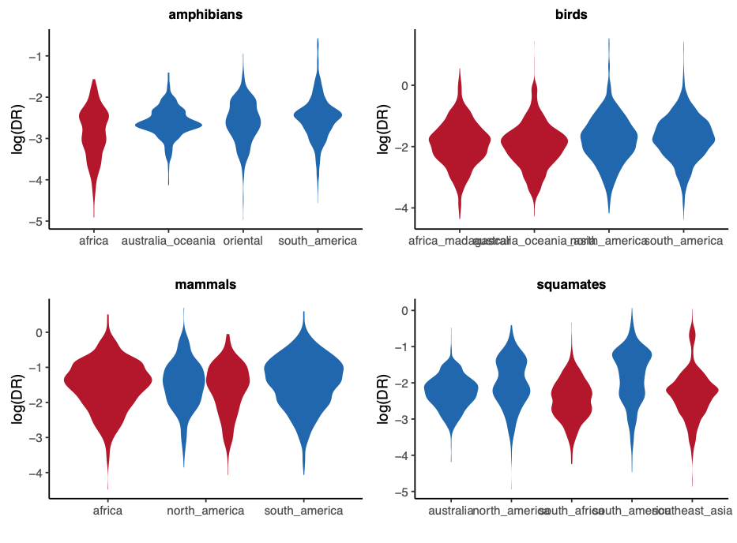

In general, speciation is faster in cradles than in museums, but the effect size is not large.

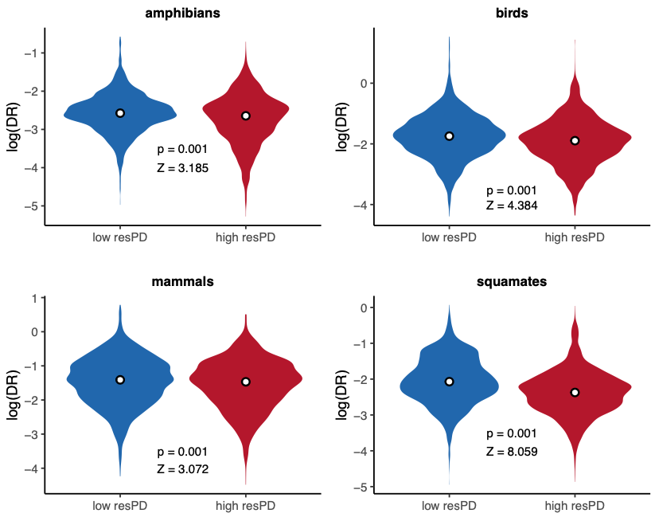

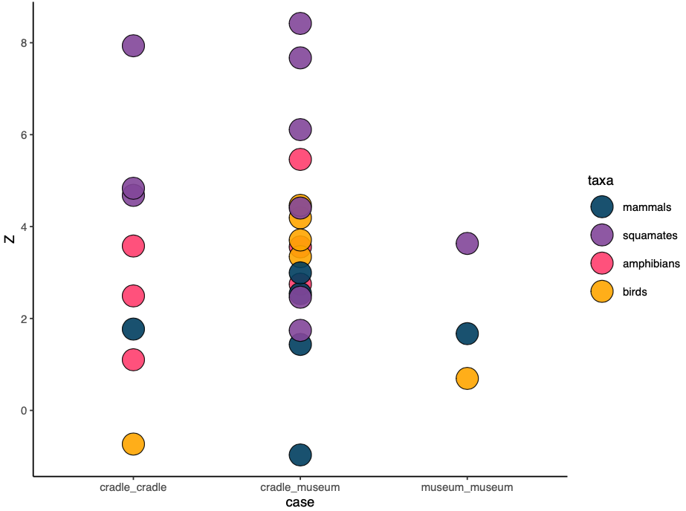

Comparison of speciation rates between cradles and museums (are the differences between cradles and museums larger than between cradles and between museums?). The difference found between museums and cradles is not that different to the difference found between cradles and between museums.

Discussion

The integration of phylogenetic metrics in the analysis of diversity allows for a more informed understanding of the evolutionary and ecological processes underlying current spatial patterns of biodiversity. Here we addressed the geographic distribution of richness-corrected phylogenetic diversity (residual PD) for four major vertebrate clades (amphibians, squamates, birds, and mammals), identifying the areas of greatest concentration of high and low residual PD and finding consistently low levels (more closely related species than predicted by richness) in America and high levels (more distantly related species) in Africa for all groups (Figure maps). Further, we found a negative but weak relationship of recent speciation rates with residual PD, indicating some role, though limited, of recent speciation in generating this pattern. Finally, our results show ambiguous and low to no effect of evolutionary time and climatic variables on the differentiation of regions with highest and lowest residual PD.

There are multiple processes that can lead to certain patterns of residual PD, and therefore the specific processes underlying such patterns might vary from one region to another and among different taxonomic groups (Davies and Buckley 2011). Here we discuss some of the processes that could be generating the patterns we found, attending to historical, biogeographic, and ecological dynamics of vertebrates in different continents. We found that the American continent is consistently a region of low residual PD across vertebrate clades. Likewise, Africa consistently harbors high levels of residual PD for all groups. Previous work on mammals (Davies and Buckley 2011) suggested that the high residual PD found in Africa might reflect that many of the extant mammal clades have an African origin (Lillegraven et al. 1987). While this is a plausible explanation, we argue that the consistencies among vertebrate clades with disparate biogeographic origins might indicate that the factors generating this pattern are common for all groups, regardless of their geographic origin or historical biogeographic dynamics. Following this reasoning, attending to the environmental and geologic history of different regions that have potentially affected all vertebrates might give deeper insights into the generation of this geographic pattern. For example, the fact that America, and particularly South America, has low levels of residual PD relative to the consistently high values in Africa for all groups (Figure maps) likely reflects the recent diversification of multiple current clades following migrations after the formation of the Isthmus of Panama coupled with the extinction of ancient lineages (Davies and Buckley 2011; Webb 1976; Webb 2006). This is consistent with the ubiquitous negative relationship observed between residual PD and recent speciation rates which, although weak, reflects that recent speciation is one of the processes at play in the unfolding of vertebrate diversity dynamics (Figure DR~resPD). Taken together, these results might point at recent climatic or geographic events (e.g., reconfiguration of continents) as a primary driver of spatial patterns of diversity dynamics in some regions by affecting, at least in part, recent levels of speciation.

However, the heterogeneity in residual PD patterns among vertebrate groups in other parts of the world (e.g., Eurasia and Australia; Figure maps) indicates that species’ intrinsic (i.e., biological, ecological, or morphological) characteristics might also have a role in the generation of these patterns. For example, the Malay Archipelago shows especially high residual PD for birds relative to the other vertebrates, while parts of Australia present low residual PD for amphibians and squamates but high residual PD for mammals and especially birds (Figure maps). One explanation for these differences may reside in the ecological and functional differences among clades. The high vagility of birds, which enabled the repeated colonization of the islands in Southeast Asia and Australia (REF?), might be the cause of the higher values of residual PD found in the region for this clade resulting from the arrival of lineages with different phylogenetic origins, as opposed to isolated radiations which might be more frequent in organisms with lower dispersal abilities. High residual PD of squamates in this area might be related to multiple waves of island colonization during intervals of low sea levels (Inger and Voris 2001), although this also affected mammals (e.g., Mercer and Roth 2003) and amphibians (REF), which do not show comparable patterns of residual PD. On the other hand, the low residual PD of squamates in arid Australia and of amphibians in the temperate woodlands of the northern and eastern coasts of Australia is likely the result of a few massive radiations (see the phylogenetic trees in Figure maps) facilitated by the adaptation to the environmental conditions and specialization within those biomes, which have led to a community assembly driven by proportionally more closely related species (REFS). Finally, geographic patterns of residual PD might also be partially generated by evolutionary ancient lineages that inhabit certain regions. This could be the case of dibamid reptiles in Southeast Asia, paleognath birds in Australia, or marsupial mammals in Australia and North America.

Apart from differences in trait- and environment-mediated speciation and dispersal, extinction might also be a major driver of diversity, diversification and biogeographic patterns (). Extinction might act generating both increasing and decreasing phylogenetic diversity, depending on the age of the lineages more prone to extinction. High residual PD regions might result from the extinction of species from relatively recent radiations, mainly reducing communities to species with a distant evolutionary relationship, while low residual PD may arise in regions where extinction rates are higher for relatively old diversity (Vasconcelos et al. 2022). The exploration of extinction dynamics and, critically, the inclusion of fossil data, might help to further disentangle the factors underlying this and other geographic patterns of vertebrate diversity.

EXTEND?: Extinction. Erwin 2008. Pyron 2014.

The variety of factors that might be generating residual PD geographic patterns is consistent with previous results indicating that the distribution of diversity is strongly subjected both to extrinsic (e.g., the paleogeographic history) and intrinsic (e.g., ecomorphological or niche-related) factors (Pyron 2014; Menéndez et al. 2021). In this sense, mountainous regions (a universally recognized driver of diversity and evolutionary processes) can have very different ecological roles depending on how the species’ ecological preferences relate to environmental features. Namely, they can act as a source of new diversity, promoting speciation due to habitat diversity across an elevational gradient (REFS), and they have also been reported as important refugia and reserves of cold-adapted diversity during periods of climate warming events (REFS). Likewise, deserts, which have been recurrently considered sinks of diversity (i.e., regions harboring distantly related species due to a lack of within-system diversification; Crisp et al. 2009) might in fact harbor low levels of residual PD, like the Australian deserts for squamates and the North American deserts for birds, mammals and squamates (Figure maps).

This ecological versatility of physiographic features might be responsible for the lack of a clear relationship between environmental variables and residual PD (Figures climate), although some segregation is apparent in the climate space between the regions of highest and lowest residual PD, especially in birds and mammals (Figure climate space). Additionally, the fact that multiple processes can lead to similar patterns of residual PD probably explain why we did not find a clear effect of evolutionary time or lineage accumulation dynamics on the differences between regions of high and low residual PD (Figure LTT plots). While time has been reported as a primary driver of diversity gradients in some systems (e.g., Miller and Román-Palacios 2021) and might be reflected in age differences among biotas in different regions, here we did not find the expected relationship between more closely related lineages (low residual PD) and younger ages. Likewise, a differential pattern of lineage accumulation between regions of high and low residual PD would be a plausible expectation. Specifically, as potential scenarios, we could expect a relatively linear or constant accumulation of species in regions of high residual PD, maybe resulting in the maintenance of ancient lineages, while in regions of low residual PD we might expect a community build-up marked by alternating periods of high diversification and stasis in lineage dynamics. However, our results show an ambiguous pattern in this respect, without a clear segregation between regions of low and high residual PD. This, together with the mild differences in recent speciation between species from low and high residual PD regions (Figure regression, Figure violin plots), might be an indicative that the phylogenetic patterns of extant species alone cannot account for the evolutionary dynamics we found across vertebrate clades, which in turn suggests that dispersal and/or deep-time diversification might be key for understanding these results.

The study of phylogenetic diversity patterns and their underlying causes is not only important to understanding how different factors operate and shape the evolutionary history. Our results might also be especially relevant from a conservation perspective. In fact, the need of integrating the evolutionary relationships of the species at the regional scale to inform conservation policies has been stated for decades (Faith 1992), in opposition to conservation approaches that consider only levels of species richness. The geographic deviations of phylogenetic diversity from species richness (i.e., patterns of residual PD) might provide essential information to develop proper conservation strategies. Regions with high residual PD maximize the conservation of phylogenetically distinct lineages, helping to preserve larger portions of evolutionary history. However, it might not be sufficient to prioritize those areas, since regions with low residual PD, on the other hand, potentially act like sources of diversity, where new species are originating. Thus, combining the conservation of regions both with high and low residual PD might be an effective way to attend to past as well as future diversification areas. Considering additional factors, such as the stability or turnover of communities, and therefore the degree of opportunity for their permanence or demise, might prove a critical practice to integrate in the decision of where to invest conservation resources. Studying geographic patterns of diversity dynamics is the baseline to carry out these practices, which in turn might stand as the only valid approach to mitigate the effects of the undergoing global environmental change.

#####

intro

The terms 'cradles' and 'museums', referring to regions of high instability, heterogeneity and species turnover (cradles) and regions of long-lasting environmental stability and taxonomic diversity (museums) have been very popular in the macroecology literature since Stebbins [-@Stebbins1974] proposed this metaphor. Even though the dichotomous interpretation of these terms has resulted in an inappropriate simplification or directly in a wrong use [@Vasconcelos2022], it is still important to identify the geographically uneven distribution of diversity dynamics to search for their ultimate historical, ecological, and evolutionary drivers.

Meseguer et al. 2022 and others by Meseguer (GEB 2018, GEB 2020, Evolution 2020).

The modern use of the terms museum and cradle and their original meaning [@Vasconcelos2022].

Whether these particular words are used or not, there are regions that show clearly distinct diversity patterns in terms of number of species (species richness) and how closely related those species are (phylogenetic diversity), indicating the existence of differences in their evolutionary dynamics. Although the geographic patterns of species richness and phylogenetic diversity are ever more well-characterized, the role of different factors in generating such patterns is not clear in most cases. Diversification rates, and (in the light of the methodological difficulties of studying extinction at global escales) more particularly speciation rates, are one of the most frequently invoked factors when characterizing biodiversity patterns, but their effect remains ambiguous in the context of global patterns of vertebrate diversity.

Another advantage of the development of phylogenetic methods…thing that we can do with phylogenies is inferring the diversification dynamics of groups, and check if the uneven geographic patterns that we observe today are produced by differences in speciation and/or extinction rates.

The use of PD-based metrics to investigate evolutionary dynamics (spatial phylogenetics, Mishler 2023 JBI). Might reflect ecological processes of community assembly: environmental filter (low PD: closely related species coexist because there is a strong environmental filter that favors some particular ecological preferences, that the species in a clade share) vs competition (high PD: closely related species compete for resources, so only distantly related species coexist).

In this study, we use global distribution and phylogenetic data for the major clades of terrestrial vertebrates (amphibians, birds, mammals, and squamates) to characterize the geographic patterns of tetrapod diversity dynamics. Specifically, we identified areas that, based on their richness and phylogenetic diversity levels, can be considered as “cradles” (here used as regions of especially low phylogenetic diversity relative to their richness, or low residual PD) and “museums” (here used to refer to regions of high residual PD). We are aware of the ongoing debate on the use of these terms [@Vasconcelos2022], and we agree with the detrimental effect of their wrong or deficient use, as well as with the prioritization of investigating the processes driving biodiversity patterns. Therefore, our primary goal is to characterize diversity dynamics (independently from the use of specific terms) and, more importantly, to explore factors that could be generating such patterns. Particularly, we aim to determine the role of recent speciation and other factors (e.g., time, environment) in generating the present-day distribution of tetrapod diversity dynamics.

discussion

Although our results indicate that regions with high or low resPD might have a common origin, we did not find a shared pattern of lineage accumulation, or consistent climatic conditions. Each group show high and low resPD regions in different climates. ….

The indomalayan region show high resPD for birds and squamates. This is congruent with the high dispersal habilities of birds, that have repeteadly colonized the islands of the indomalayan archipielago (and Asutralia), generating more phylogenetic diversity than if they only had diversified within the islands. Squamates, although they have no high dispersal habilities, show a high resPD probably related to the repeated colonization of islands during intervals of low sea-level (Inger and Voris 2001). Although this affected too to mammals and amphibians…

Australia is a region of low resPD for squamates, specifically the desert, which is well known as a region of strikingly high richness for squamates. Australia shows also low resPD in the coast for amphibians….. for birds, Australia shows high resPD (guille + lizzy). Mammals also show high resPD regions in Australia…  
mammals in north american differences

This is congruent with the observed segregation in the climatic space (temperature vs precipitation) between high and low resPD cells, at least for some groups (especially birds and mammals). The more stable climatic conditions for each group show high resPD, while “harsh” environments show low resPD.

Negative relationship resPD ~ speciation but low effect.

Lack of effect of speciation on other diversity patterns.

We did not find the expected differential pattern of lineage accumulation between regions of high and low residual PD (i.e., museums and cradles, respectively) (LTT plots). However, the geographic patterns of residual PD might be partially derived from the richness levels of ancient lineages (i.e., species richness in the past). In mammals, for instance, this would reflect that many of the extant clades have an African origin (Lillegraven et al. 1987), making Africa a museum of diversity, while richness in South America is much younger as a result of the recent diversification of multiple current clades following migration after the formation of the Isthmus of Panama and the extinction of old lineages (Davies and Buckley 2011; GABI references: Webb 1976; Webb 2006), resulting in a cradle in this region.

It seems like there is some segregation in the climatic space (temperature vs precipitation) between museums and cradles, at least for some groups (especially birds and mammals), although the relationship between the climatic variables and residual PD is low.

Factors that may shape biodiversity dynamics.

Dispersal.

Extinction. Erwin 2008. Pyron 2014.

The interplay of environment (e.g., habitat filtering) and evolutionary time (e.g., geologically driven vicariance) drive current distribution patterns in amphibians (Pyron 2014).

The fact that the places with high speciation rates at present are not the places with more closely related diversity relative to their species richness might indicate that historical diversification trends (rather than present-day processes) are driving geographical patterns of global diversity. This, in turn, may indicate that present-day geographic patterns of speciation might be more related to future biodiversity dynamics (Schluter and Pennell 2017).

Another interesting point might be that regions of high residual PD do not consistently coincide with harsh or arid regions, which are often considered sinks of biodiversity (Crisp et al. 2009). In fact, some deserts might be sources of diversity like the mammal and bird cradles in North America, and the squamate cradles in North America and Australia (Fig. MAP). This is consistent with previous results on arid lizards in North America (Wiens et al. 2013). We do find that some hyper-arid regions harbor high levels of residual PD: the Arabian Peninsula and parts of the Sahara desert for squamates, Australia for birds, some parts of Australia for mammals, and then some areas of the Palearctic and the Nearctic for amphibians, which might be a group particularly not suited for those cold and low-humidity regions.

Something about mountains? They can act as cradles () and museums ().

Conservation. Importance of considering phylogenetic diversity, but also there is the risk of just maximizing PD: low PD might be indicative of intense diversification, or high turnover, and in some cases preserving those might be more interesting than preserving potentially more stable environments of high PD (Davies and Buckley 2011).

Effect of environmental change and habitat alteration in PD (Swan et al. 2022).

Our results can be useful for directing conservation efforts. Regions with high resPD maximize the conservation of different lineages. Regions with low resPD, on the other hand, are regions where new species are generating (sources). So combining the conservation of regions both with high and low resPD could be beneficious to past as well as future diversification.

References

**Figures (in folder figs)**

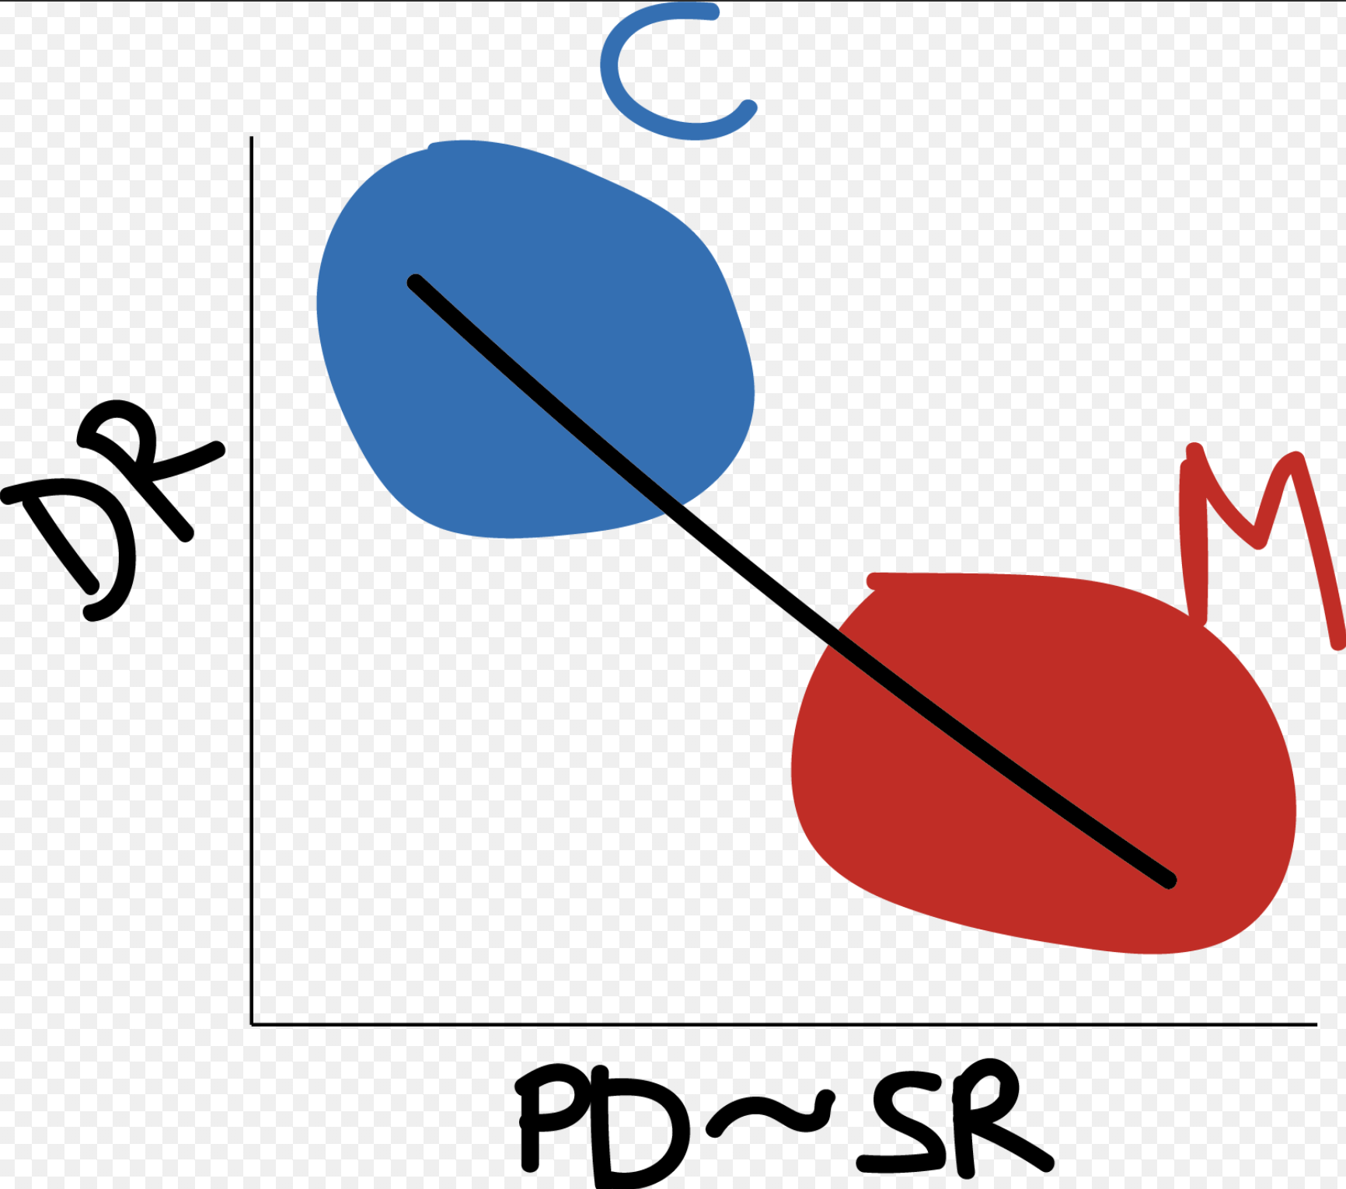

Figure 1. Conceptual representation of the expected relationship between speciation rates and phylogenetic diversity (PD) relative to species richness.

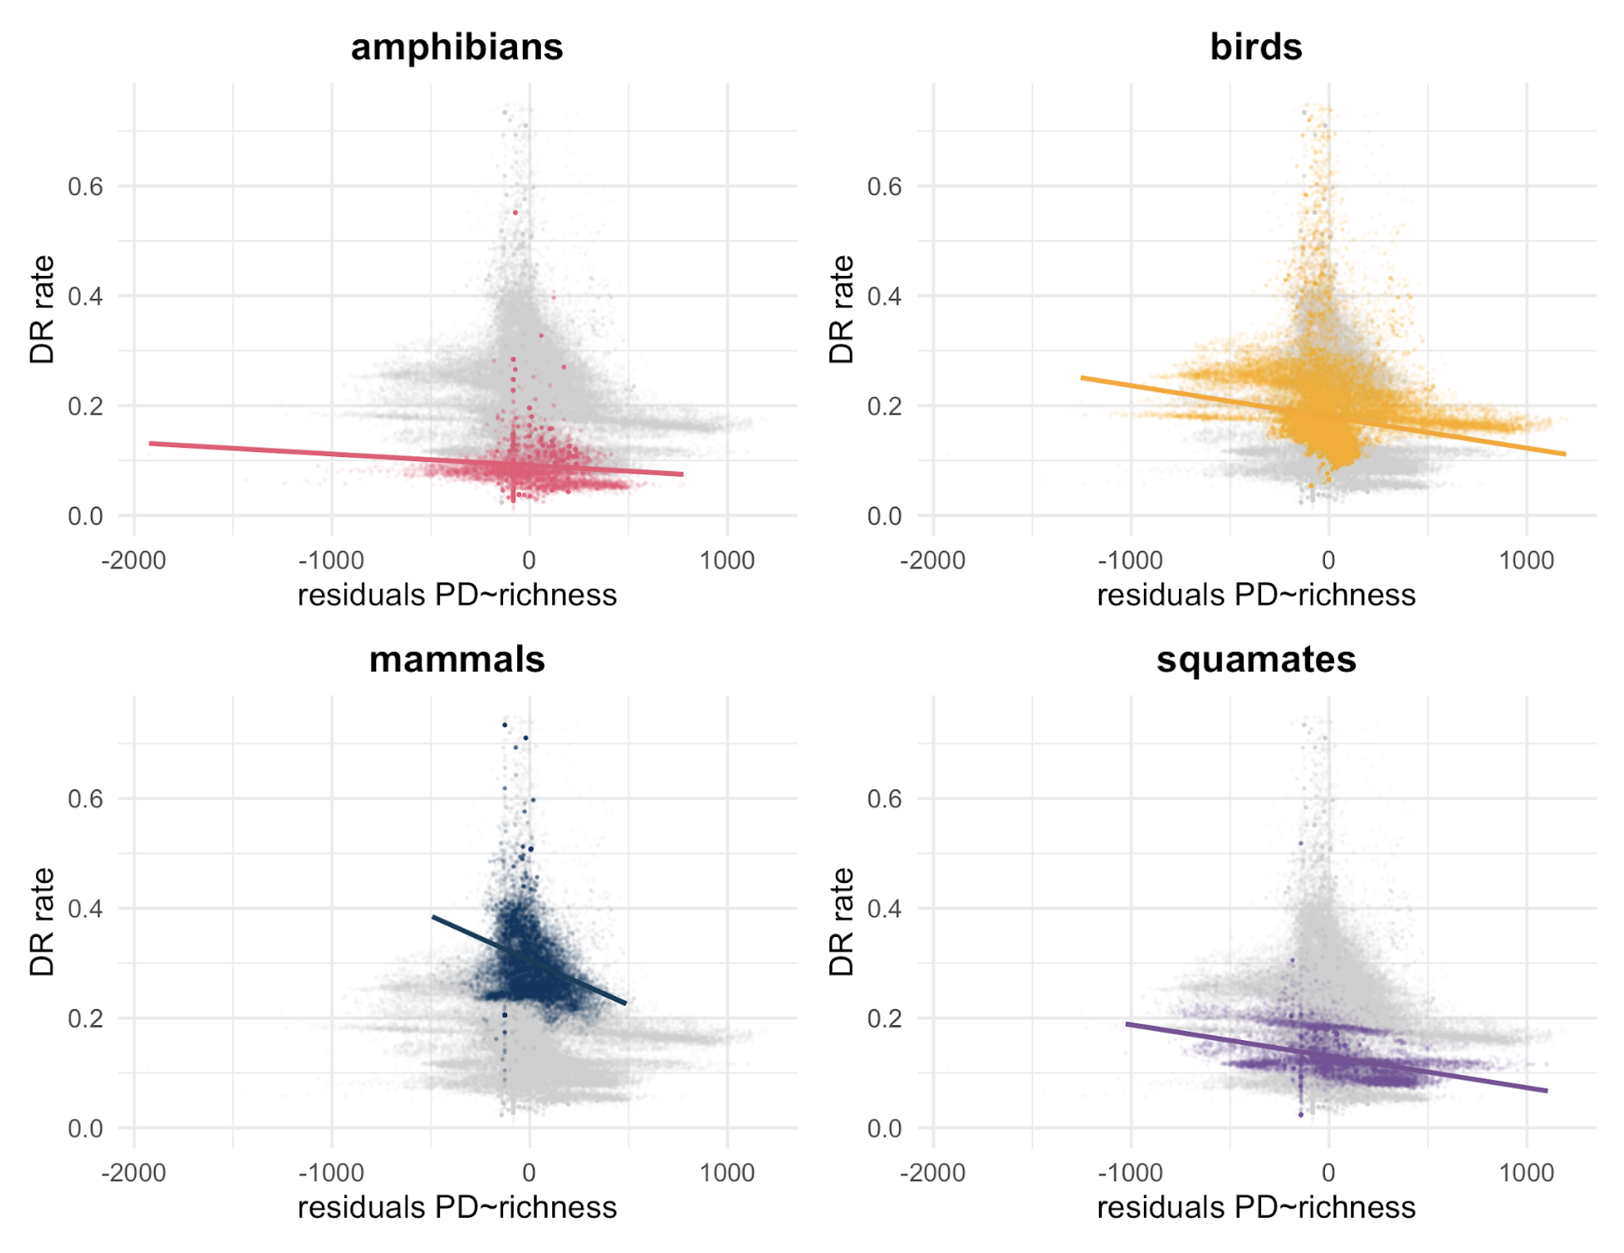

Figure 2. Relationship between DR rates and the residuals resulting from a regression of `PD ~ Richness` for all four groups of terrestrial vertebrates.

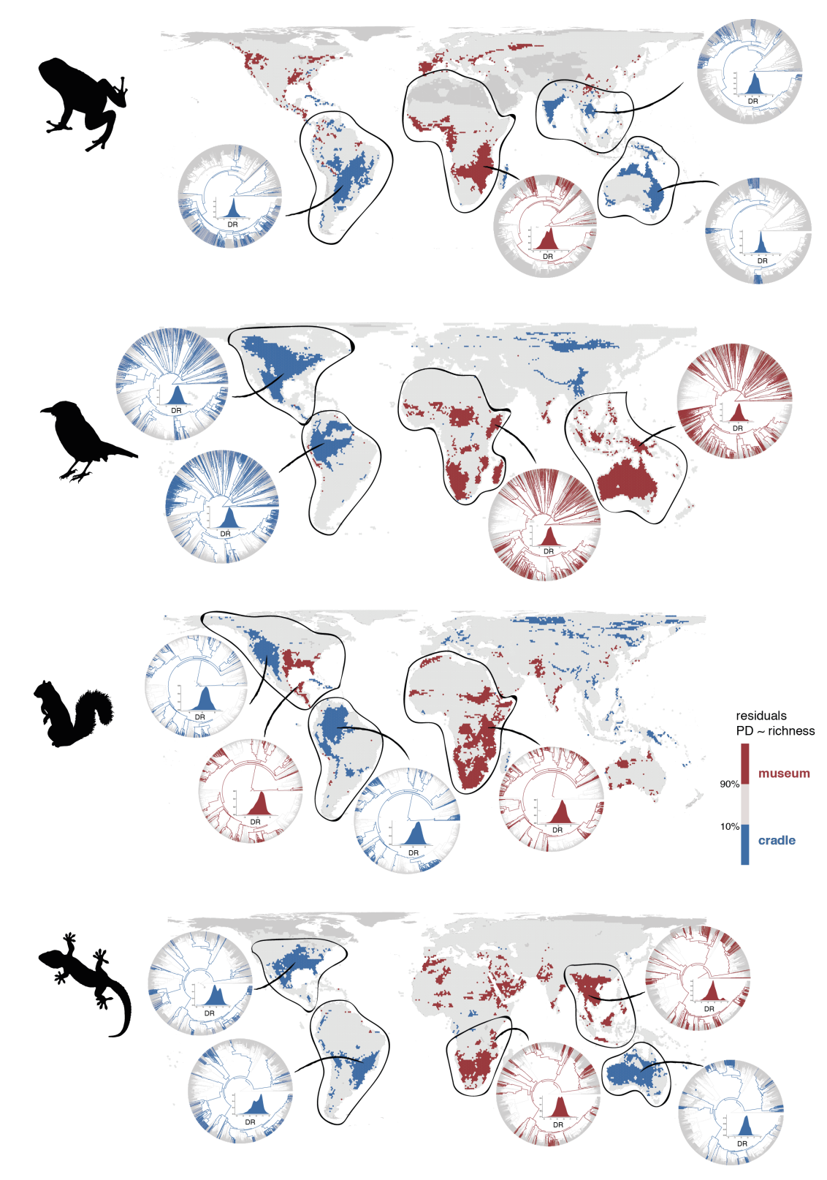

Figure 3. Geographic distribution of areas with the 10% lowest (in blue) and highest (in red) residual PD for terrestrial vertebrates. The phylogenetic relationships of species present in some regions are also shown to illustrate the evolutionary differences of regions with high and low residual PD. Silhouettes extracted from 'phylopic' (www.phylopic.org).